Chapter 2 Question 4, 13, 23 Michael Streyle

##   
## Call:  
## lm(formula = GPA ~ ACT)  
##   
## Coefficients:  
## (Intercept) ACT   
## 2.11405 0.03883

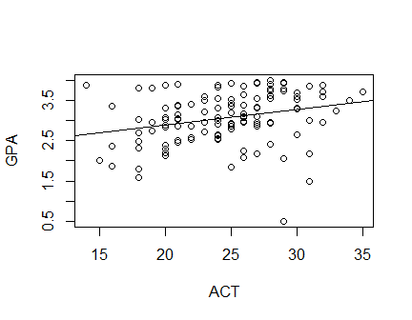

##   
## CONFIDENCE LIMITS FOR INTERCEPT AND SLOPE:

## 0.5 % 99.5 %  
## (Intercept) 1.273902675 2.95419590  
## ACT 0.005385614 0.07226864

##   
## HYPOTHESIS TESTS FOR INTERCEPT AND SLOPE:

## Estimate Std. Error t value Pr(>|t|)  
## (Intercept) 2.11404929 0.32089483 6.587982 1.304450e-09  
## ACT 0.03882713 0.01277302 3.039777 2.916604e-03

##   
## CONFIDENCE INTERVAL FOR A MEAN RESPONSE:

## fit lwr upr  
## 1 3.201209 3.084149 3.318269

##   
## PREDICTION INTERVAL FOR AN INDIVIDUAL RESPONSE:

## fit lwr upr  
## 1 3.201209 2.161538 4.24088

##   
## ANOVA TABLE:

## Analysis of Variance Table  
##   
## Response: GPA  
## Df Sum Sq Mean Sq F value Pr(>F)   
## ACT 1 3.588 3.5878 9.2402 0.002917 **  
## Residuals 118 45.818 0.3883   
## ---  
## Signif. codes: 0 '***' 0.001 '**' 0.01 '*' 0.05 '.' 0.1 ' ' 1

## DF Sum Sq  
## Corr. Total 119 49.40545

##   
## CORRELATION COEFFICIENT:

## [1] 0.2694818